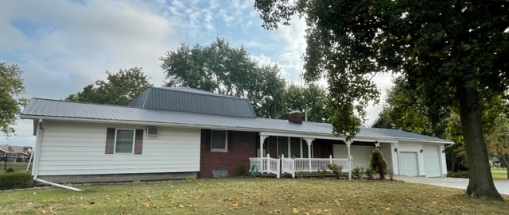

Listing # | Property Address | Property Type | RMS | BRMS | Baths* | Location | Price | Finished Sq. Ft
 | 71474 CR 7 | 1 ½ story | 8 | 3-4 | 1 ½+1/2 | Nappanee | $269,900 | 2536 +/-

Phil Hahn & Associates
Realtors & Auctioneers
1203 East Market Street
Nappanee, IN 46550
Phone: 574/ 773-4184
Fax: 574/ 773-4186
email: hahn@hahnrealtyandauction.com
www.hahnrealtyandauction.com
Information Herein Believed to Be Accurate But Not Warranted

Salesman: Laurie Sumpter
laurie@hahnrealtyandauction.com
Telephone 574-202-0056
Tax Code: 20-14-29-100-002.000-028
Owner : Miller Trust
Legal Descript: 208.708 x 208.708FT IN SW COR NW EX .003 ROW
SEC 29 .997A

Like us on Facebook!

Lot Size | .997 A lot | W.W. Carpet | X |  | 1st Floor | Other
Annual Tax | $2431.54/yr w/ ex | Draperies | X-blinds | Approx. Sq. Ft. | 2056 | 480
Construction | Wood frame | Softener | X | Living Room | 13x19
Age-Cond. | 1963-good | Disposal | X | Dining Room | }16x21
Possession | Neg. | Microwave | X | Kitchen | }16x21
School District | WaNee-Woodview | Dishwasher | X | Family room | 20x20
Terms | Cash, conv. | Refrigerator | X | Bedroom | 15.5x19 | 19 x 20
NIPSCO avg. | Empty | Range-G/E | X | Bedroom | 14x19
Type Heat | GFA ** | Air. Cond. | X | Bedroom | 8.5x11.5
Type Wtr.Htr | Gas-older | Fireplace | X | Bedroom | X
Type Roofing | Metal | Insulation | X | Baths | 1 ½ | ½
Interior Walls | Drywall/plaster | Storm Doors | X | Utility Room | Main level
Type Siding | Vinyl, brick | Storm Wds. | X | Type Floors | Carpet
Elec. AMPS | 100 | City Water | - | Garage | 4-car attached
Type Windows | Double hung | Storm Sewer | - | Basement % | Partial
Type House | 1 ½ story | San. Sewer | - | Fenced Yard | No
Zoning | R | Well 2” | X | Type Drive | Asphalt
Township | Union | Septic | X | Patio yes + | 14x20 sun room
Remarks: Large 1 ½ story home on a beautiful 1-acre lot in WaNee school district. Spacious rooms, nice kitchen,
awesome sunroom, main floor laundry, and a kitchen in the basement for the family time. * Full bath & 2 half baths.
Selling “AS IS” home is in a trust. This home has lots to offer a growing family with a convenient location too!
**electric baseboard in some rooms for supplemental heat if needed. A/C unit in master bedroom also extra.
Generator, Shed, Nice patio, maintenance free exterior and a 4-car attached garage make this the perfect
Place to Call Home! Bathroom in Basement doesn’t work.

